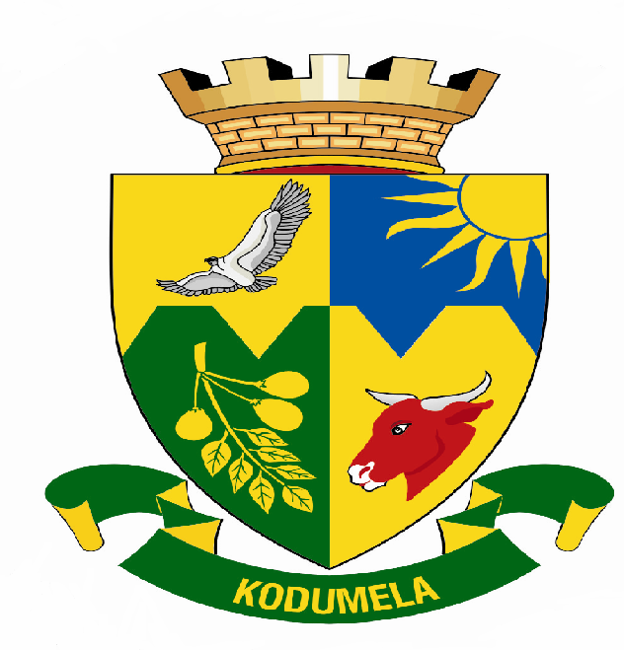
Blouberg Municipality
P.0 Box 1593
SENWABARWANA
0790
Tel: 015 505 7100
Fax: 015 505 0568/0296
Email:matloup@blouberg.limpopo.gov.za

MEDIA RELEASE
5th Annual Ward Committees Forum

Blouberg Municipality will be hosting the fifth Annual Ward Committees Forum from 17 - 19 August 2007. The municipality has been rated amongst the few municipalities with best practices in terms of public participation. Earlier this year the Department of Provincial and Local Government visited the municipality to learn how best the practices can the filtered to other municipalities in order to intensify public participation in the country.

The 5th Annual Ward Committees Forum will focus on the 2006/07 annual report from the ward committees and also the development of the 2007/08 annual plan in line with the municipal IDP/Budget 2007/08.

Your institution is invited to witness the event to be held as follows:

Date : 17 – 19 August 2007
Venue : Eiland Spa (Tzaneen)
Time : 14h00

Your presence at the event will be highly appreciated.

Issued by Communications on 16 August 2007.

For enquiries contact:
Manager Communications: Ms Phuti Matlou
Cell: 083 395 8417
Tel: 015 505 7100

